**P510/2**

**PHYSICS**

**Paper 2**

**August**

**2 ½ Hours**



**ELITE EXAMINATION BUREAU MOCK 2019**

**Uganda Advanced Certificate of Education**

**Physics**

**Paper 2**

**2 Hours 30 Minutes**

**INSTRUCTIONS TO CANDIDATES**

* *Answer* ***five*** *questions, taking atleast one from each of the section,* ***A, B, C*** *and* ***D,*** *but not more than* ***one*** *question should be chosen from either section* ***A*** *or* ***B****.*
* *Any additional question(s) answered will* ***not*** *be marked.*
* *Mathematical tables and square paper are provided.*
* *Non-programmable scientific calculators may be used.*

**Assume where necessary,**

One electron volt (*eV)* = 1.6 x 10-19J

Acceleration due to gravity, g = 9.81ms-2

Electronic Charge, e = 1.6 x 10-19C

Electronic mass, me = 9.1 x 10-31kg

Plank’s constant, h = 6.6 x 10-34Js

Speed of light in vacuum, c = 3.0 x 108ms-1

Avogadro’s number, NA = 6.02 x 1023mol-1

Charge to mass ratio, e/m = 1.8 x 1011Ckg-1

The Constant, = 9.0 x 109F-1m

Permeability of free space, μ0 = 4.0π x 10-7Hm-1

Permittivity of free space, ε0 = 8.85 x 10-12

**Turn Over**

**SECTION A**

1. (a) Define the following terms

(i) Critical angle (1mark)

(ii) Total internal reflection. (1mark)

(b) (i) Describe a method of determining the focal length of a convex lens placed inside a tube. (5marks)

(ii) Derive an expression for the formula in(i) above. (3marks)

(c) A large convex mirror has a radius of curvature of 1.5m. A person stands at a distance of 10m infront of the mirror.

(i) How far is the persons’ image from the mirror? (2marks)

(ii) The person walk towards the mirror at a constant velocity of 2.0ms-1, determine the velocity of the persons’ image in cms-1. (3marks)

(d) An extended object O of height 2.0cm is placed at a distance **a** from the principal focus F of a concave mirror. The mirror forms areal inverted image I of height 1.0cm at a distance **b** from F. if the focal length of the mirror is f.

(i) show that $f = (ab)^{\frac{1}{2}}$ (3marks)

(ii) If b = 5.0cm, find the focal length of the mirror. (2marks)

2. (a) Distinguish between compound microscope and astronomical telescope. (2marks)

(b) An astronomical telescope in normal adjustment has an objective lens of focal length 100cm and magnifying power of 20. If the diameter of the eye ring of the telescope is 1.0cm, determine the

(i) lens separation (3marks)

(ii) diameter of the objective lens. (3marks)

(c) (i) Derive with the aid of a ray diagram, an expression for the angular magnification of a compound microscope in normal adjustment. (4marks)

(ii) Explain why the instrument in(i) above is free from chromatic aberration when the observers’ eye is placed very close to the lens. (3marks)

(d) A compound microscope is formed from two convex lenses of focal length 1.0cm and 5.0cm respectively. An object is placed 1.1cm from the objective and a final image is formed 32.0cm from the eye piece lens. Determine the magnifying power of the instrument, if the near point is considered to be 25cm from the observers’ eye. (5marks)

**SECTION B**

3. (a) (i) Define the terms, Beats and Doppler effect. (2marks)

(ii) Two tuning forks A and B are sounded together producing beats with a frequency of 10Hz. If a small piece of plasticine is fixed to fork B, the beat frequency decreases. If the frequency of A is 300Hz, find the original frequency of B. (4marks)

(b) A whistle fixed at the end of a piece of string is whirled round in a horizontal circle of radius 1.0m at a speed of 30m-1. If the frequency of the note emitted by the whistle is 1015Hz. Calculate the minimum and maximum frequencies heard by the stationary observer standing at some distance away but in the vicinity of the whistle, hence determine the beat frequency. (Velocity of sound in air = 330ms-1). (4marks)

(c) Distinguish between longitudinal and transverse waves. (3marks)

(d) Describe a graphical method of determining an end correction in tube closed at only one end (5marks)

(e) What are,

(i) infrasonic waves? (1mark)

(ii) ultrasonic waves? (1mark)

4. (a) (i) Define the term diffraction as applies to waves. (1mark)

(ii) State two factors that affect the extent of diffracted waves through an opening. (2marks)

(b) Describe an experiment to determine the wave length of the light used by Young’s double slit experiment using a travelling microscope. (6marks)

(c) (i) What is polarized light? (1mark)

(ii) Outline the four ways of producing plane polarized light. (4marks)

(d) (i) What is meant by interference by division of amplitude. Illustrate your answer using a sketch diagram. (2marks)

(ii) In a Lloyd’s mirror experiment, the source slit so and its virtual Image S1 lie in a common plane 0.20m normal to the plane of the mirror and behind the left edge of the mirror. The mirror is 0.3m long and a screen is placed normal to the mirror and at the right edge, if the perpendicular distance from so to the mirror is 2mm and the wave length of light used in the experiment is 6.0 x 10-7m. Determine how far the first bright band is from the right edge. (4marks)

**SECTION C**

5. (a) Define the terms

(i) magnetic flux (1mark)

(ii) magnetic meridian (1mark)

(b) (i) Write down the expression for the magnetic flux density at a perpendicular distance d, from a straight wire carrying a current I in air. (1mark)

(ii) Figure 1 shows a smooth rigid copper wire PQ of length 9.81cm and mass 4 x 10-5Kg sliding down guided copper rails with perfect electrical contact and is directly above wire NO resting on a horizontal wooden table. If the operation between wires No and PQ when at equilibrium is 7.2mm, find the current I flowing through the system. (4marks)

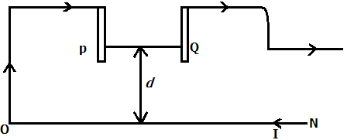

(c) Define the terms magnetic torque and electromagnetic moment of a current – carrying coil placed in a magnetic field and state the SI unit of each quantity. (4marks)

(d) (i) With the aid of a diagram, derive the expression for the torque experienced by a rectangular coil of plane Area A1 having N turns of wire each carrying a current I in a magnetic field of flux density B. assume the initial angle of inclination of the plane of the coil and the magnetic field is θ. (5marks)

(ii) A flat circular coil of 50 turns and of mean radius 20cm is in a fixed vertical plane and has current of 5A flowing through it. A small square coil of side 1cm and having 120 turns is suspended at the centre of the circular coil in a vertical plane at an angle of 30o to that of the large coil. Calculate the torque experienced by the small coil when a current of 2 x 10-3A is passed through it. (4marks)

6. (a) (i) Define the term electromagnetic induction. (1mark)

(ii) Distinguish between self induction and mutual induction.(3marks)

(b) What are Eddy currents? (2marks)

(c) (i) State the laws of electromagnetic induction. (2marks)

(ii) Describe an experiment to verify lenz’s law. (6marks)

(d) A copper rod WY of resistances 0.2Ω is moved across a uniform magnetic field of flux density 0.84T perpendicular to the plane of the paper at 0.6ms-1 when a force is applied in the direction shown in figure 2.

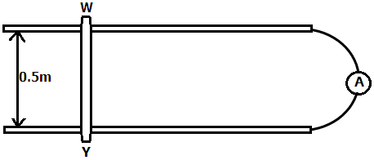

(i) Determine the ammeter reading (3marks)

(ii) Explain why rod WY attains a constant velocity. (3marks)

7. (a) (i) Distinguish between Resistance and reactance of a coil. (2marks)

(ii) Derive an expression for the impedance of the coil in(i) when connected across an a.c source. (3marks)

(b) A pure inductor of 2.0H is connected in series with a 500Ω resistor across a.c mains having a frequency of 50Hz. A high resistance voltmeter connected across the mains reads 240V. Determine its reading when connected across.

(i) the resistor

(ii) the inductor

(iii) Why is the sum of the values in(i) and (ii) not equal to 240V?

(c) (i) Describe with the aid of a diagram, how a repulsion type of hot Iron ammeter works. (6marks)

(ii) State one advantage of the instrument in(i) over a moving coil ammeter. (1mark)

**SECTION D**

8. (a) (i) Define the term electric field. (1mark)

(ii) Two parallel metal plates of the same size are oppositely charged and a small neutral metal sphere is placed mid-way between the plates sketch electric field lines between the plates in the presence of the sphere. (3marks)

(b) (i) State Gauss’s law of electrostatics. (1mark)

(ii) Show that the electric flux due to a spherical surface concentrically enclosing a charge Q in free space is given by $\frac{q}{ε_{o}}$

(c) Figure 3 shows two point charges of +5.0 $μc$ and -3 $μc$ placed at points A and B a distance of 1.8m apart. Distance between p and q is 1.2m while Aq = 0.9m.

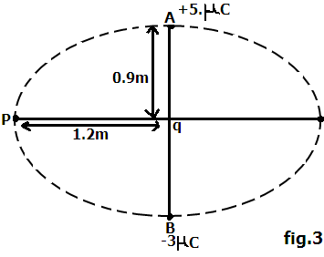

Determine the work done in moving a charge +3.0 $μc$ from P to q. (4mrks)

(d) (i) Explain the term corona discharge. (3marks)

(ii) Describe the structure and mode of operation of an electrostatic generator. (5marks)

9. (a) (i) What is a capacitor? (1mark)

(ii) Derive an expression for the effective capacitance c of two capacitors c1 and c2 arranged in series. (3marks)

(b) The circuit in figure 4 show a network of six capacitors C1, C2, C3, C4, C5 and C6 of capacitance 1 $μF_{,}$ 2 $μF$, 3 $μF,$ 4 $μF$, 4 $μF$ and 6 $μF$ respectively.

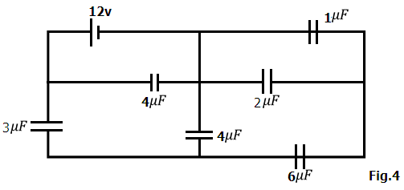

Determine the;

(i) Effective capacitance of the network. (4marks)

(ii) Total energy stored in the system (3marks)

(c) A parallel plate capacitor having all the space between the plates filled with a dielectric of dielectric constant $ε_{r}$ is connected to ad.c source and charged fully. The capacitor is then disconnected from the source then the dielectric is removed. Show that the fractional change in the p.d is given by $\left(E_{r}-1\right)$. (4marks)

(d) Describe an experiment to investigate the effect of reducing the distance between the plates of a charged capacitor on its capacitance. (5marks)

10. (a) (i) State ohm’s law. (1mark)

(ii) Give two examples of ohmic conductors and two examples of non-ohmic materials (2marks)

(b) Figure 5 shows a network of three resistors of 2Ω, 12Ω and 6Ω connected to a 12v d.c source. A perfect ammeter and voltmeter are connected as shown.

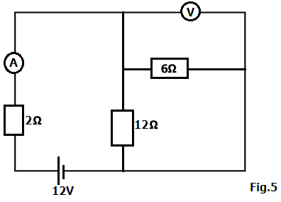

Determine the

(i) Ammeter reading (4marks)

(ii) voltmeter reading (3marks)

(c) In figure 6, cell D is an accumulator of emf 2.0V and negligible internal resistance. AB is a uniform resistance slide wire of length 1.0m and of resistance 10Ω, R1 = 5.0Ω, R2 = 1985Ω while E is a thermo couple.

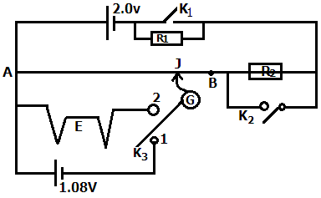

Determine the

(i) Balance length when switches K1 and K2 are closed while switch K3 is connected to position 1. (3marks)

(ii) Emf of the thermo couple E1 when switches K1 and K2 are open while switch K3 is connected to position 2 and the sliding contact J is 75.0cm from A when G shows no deflection. (3marks)

(d) Explain why

(i) Alloys are commonly used for making resistance boxes. (2marks)

(ii) Semi-conductors have a negative temperature co. efficient of resistance. (2marks)

**END**